**Champlain College - Lennoxville**

**Lab 4**

|  |  |  |  |
| --- | --- | --- | --- |
| **PROGRAM:** | 420.B0 Computer Science Technology | | |
| **COURSE:** | Database Application Development | | |
| **COURSE CODE:** | 420-450-LE | | |
| **WEIGHT:** | 6% of the final score | | |
| **DUE DATE** | Wednesday, April 17th, 2024 | | |
| **SEMESTER:** | Winter 2024 | | |
| **INSTRUCTOR:** | Caroline Fortier  cfortier@crc-lennox.qc.ca |  |  |

# Part 1

# MongoDB Advanced Queries

### Provide the Python script that generates the below data:

### Question 1

### From the **planets** collection in the **sample_groups** database, generate the following Dataframe :

|  |  |  |  |  |
| --- | --- | --- | --- | --- |
|  | **name** | **minTemp** | **maxTemp** | **avgTemp** |
| **_id** |  |  |  |  |
| **1** | Mercury | -173 | 427 | 67 |
| **2** | Venus | NaN | NaN | 464 |
| **3** | Earth | -89.2 | 56.7 | 14 |
| **4** | Mars | -143 | 35 | -63 |
| **5** | Jupiter | NaN | NaN | -145.15 |
| **6** | Saturn | NaN | NaN | -139.15 |
| **7** | Uranus | NaN | NaN | -197.2 |
| **8** | Neptune | NaN | NaN | -201 |

### Question 2

### From the **planets** collection in the **sample_groups** database, generate the following Dataframe (the first 3 columns are directly obtained from DB, the forth column is generated conditionally so that each distinct mainAthmosphere element has its own color):

|  |  |  |  |  |
| --- | --- | --- | --- | --- |
|  | **orderFromSun** | **name** | **mainAtmosphere** | **color_values** |
| **0** | 2 | Venus | CO2 | #00CED1 |
| **1** | 2 | Venus | N | #00FFFF |
| **2** | 3 | Earth | N | #00FFFF |
| **3** | 3 | Earth | O2 | #228B22 |
| **4** | 3 | Earth | Ar | #00FA9A |
| **5** | 4 | Mars | CO2 | #00CED1 |
| **6** | 4 | Mars | Ar | #00FA9A |
| **7** | 4 | Mars | N | #00FFFF |
| **8** | 5 | Jupiter | H2 | #008080 |
| **9** | 5 | Jupiter | He | #191970 |
| **10** | 5 | Jupiter | CH4 | #00FF00 |
| **11** | 6 | Saturn | H2 | #008080 |
| **12** | 6 | Saturn | He | #191970 |
| **13** | 6 | Saturn | CH4 | #00FF00 |
| **14** | 7 | Uranus | H2 | #008080 |
| **15** | 7 | Uranus | He | #191970 |
| **16** | 7 | Uranus | CH4 | #00FF00 |
| **17** | 8 | Neptune | H2 | #008080 |
| **18** | 8 | Neptune | He | #191970 |
| **19** | 8 | Neptune | CH4 | #00FF00 |

### Question 3

### From the **restaurants** collection in the **sample_restaurants** database, generate the following Dataframes(2) :

(1)'Total number of Polish cuisine restaurants grouped by borough'

|  |  |  |
| --- | --- | --- |
|  | **_id** | **total** |
| **0** | Brooklyn | 18 |
| **1** | Queens | 4 |
| **2** | Manhattan | 2 |
| **3** | Staten Island | 1 |

(2)'Total number of Italian cuisine restaurants grouped by borough'

|  |  |  |
| --- | --- | --- |
|  | **_id** | **total** |
| **0** | Manhattan | 621 |
| **1** | Brooklyn | 192 |
| **2** | Queens | 131 |
| **3** | Staten Island | 73 |
| **4** | Bronx | 52 |

### Question 4

### From the **grades** collection in the **sample_training** database, generate the following Dataframes(2) :

1. Average score per evaluation type for **class_id 350**

|  |  |  |  |  |  |  |  |  |  |  |  |  |  |  |  |  |
| --- | --- | --- | --- | --- | --- | --- | --- | --- | --- | --- | --- | --- | --- | --- | --- | --- |
| |  |  |  | | --- | --- | --- | |  | | | |  | **_id** | **avg_score** | | **0** | exam | 44.877359 | | **1** | homework | 51.021385 | | **2** | quiz | 50.923623 | |  |

1. Average score per evaluation type for **class_id 149**

|  |  |  |
| --- | --- | --- |
|  | | |
|  | **_id** | **avg_score** |
| **0** | exam | 50.06437 |
| **1** | homework | 49.66643 |
| **2** | quiz | 53.57935 |

# Part 2

# Python Matplotlib

### Generate the below graphs using part1 as you data source.

### Provide the Python script that generates the below graphs, using the matplotlib library

### Question 1 - Generate graph:

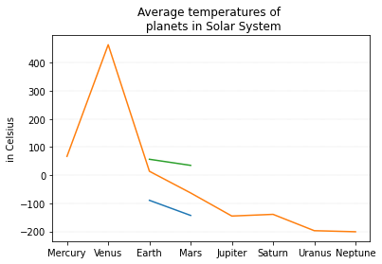

### Question 2 – Generate graph:

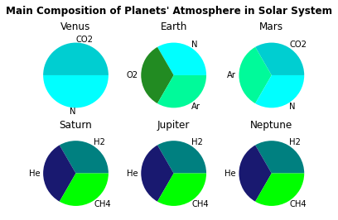

### Question 3 - Generate graph:

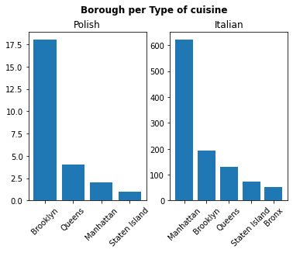

### **Bonus Question** : How could you present the same information in a more significant way?

* You can present this information in a clearer way by grouping the data of the same city with both type of cuisine. This would show the Polish data and the Italian data in a clear visual.

### Question 4 - Generate graph:

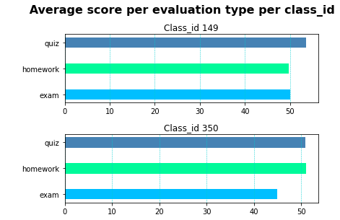

# Part 3

# Tkinter Canvas widget

Create a simple tkinter app that displays each of the graphs generated in Part 2, in a canvas widget, where each graph is selected and updated on option menu selection, as seen below.

